Arburg Technology Center (ATC) refurbished
Grand reopening of Arburg's Radevormwald location

- Refurbishment: Multi-million Euro investment in Arburg Technology Center in Radevormwald
- Fit for the future: Around 250 guests wowed by state-of-the-art facilities
- Since 1982: ATC has been offering all-inclusive package for customers based in the west and north of Germany

Lossburg, 11/06/2024
The refurbished Arburg Technology Center (ATC) in Radevormwald is back to normal operations. During the two-year modernisation phase, the Arburg staff in Radevormwald did everything possible to continue to offer customers the best support, with total dedication and flexibility. On 7 June 2024, Arburg Managing Partners Juliane and Michael Hehl, together with the Managing Directors and project leads, cut the reopening ribbon. This event, marked by an open house, followed an exclusive event the previous evening. The two-day event was attended by a total of around 250 guests. In 1982, Radevormwald was the first Arburg location outside Lossburg. Today, it is a sought-after contact point for customers and prospective buyers from the west and north of Germany.

"Our decision to undertake a multi-million Euro investment in the renovation of the ATC not only demonstrates how important our customers and staff are to us, but also emphasises the great significance of the German market for Arburg," stressed Michael Hehl, Managing Partner and spokesperson for the Arburg management team, in his speech. "Today, you can see that the wait has been more than worth it. We're all very proud of what has been created here: a building for the future that marries aesthetics with functionality and environment protection in an outstanding way."

New from old: a model of energy efficiency
Shortly after the 40th anniversary celebrations, the ATC was cleared and gutted in August 2022. All that was left was a shell, which was then outfitted from the ground up with the latest technology. The comprehensive renovations and modernisations included installing photovoltaic and geothermal systems, a triple-glazed glass facade and efficient roof insulation. Following the renovation and thanks to the use of renewable energies, the annual primary energy requirement of the ATC Radevormwald is around just 40% of that of a newly built reference building. The photovoltaic system alone, which produces almost 100,000 kWh a year, covers 60% of the total consumption. The building project is also a very clear reflection of the corporate philosophy: no matter whether developing Arburg products and processes or undertaking a building project, the name of the game is combining high tech and innovation with resource conservation and sustainability.

Two-year transition period: always there for the customer
During the transition period, the team of thirty plus were based in an office building around a kilometre away. At the temporary location, the office work and customer service hotline were able to continue 100% in house. The good, long-standing relationships with customers proved to be an advantage. For application technology and training, the Arburg staff was able to use the customers' machines on site.

State-of-the-art training rooms and technical centre
The top floor of the ATC now accommodates redesigned training rooms with state-of-the-art presentation equipment. The technical centre also fulfils the latest requirements. Ulf Moritz, Manager of ATC Radevormwald: "In the technical centre, seven injection moulding machines of the latest design with clamping forces ranging from 400 to 1,600 kN are available for our customers, for sampling, testing and training. Each is equipped with a robot system – from the sprue picker and linear Multilift robot systems to the 6-axis robot. The high-quality machine technology and equipment leaves nothing to be desired."

Evening event and open day
An exclusive event was held the evening before the reopening. The highlight was the following open day on 7 June, attended by high-ranking representatives from the company's Lossburg headquarters. The official portion included the ribbon cutting by the Managing Partners Juliane and Michael Hehl together with Managing Directors Gerhard Böhm and Guido Frohnhaus as well as ATC Director Ulf Moritz and project leads Dieter Novotny (Architecture) and Florian Schmitz (Building Services Engineering).
After this, the around 250 invited customers and partners took full advantage of the opportunity to take in the new facilities and equipment. All seven Allrounder machines were in operation, showcasing interesting applications live to demonstrate the wide range of injection moulding products and services. These included the hydraulic Allrounder 270 S with Integralpicker, which reliably processed biomaterial based on sunflower seed shells, high-performance electric machines from the Alldrive series with linear Multilift robot systems and the two-component Allrounder More 1600 with six-axis robot, which produced spatulas made from thermoplastic and liquid silicone fully automatically. The presentation of energy-efficient hybrid machine technology and the assistance functions in the Gestica control system also generated a lot of interest. The programme of events was rounded off with fascinating presentations on hot topics such as digitalisation, sustainability and hybrid machine technology.

Images

Opening ATC Radevormwald_55

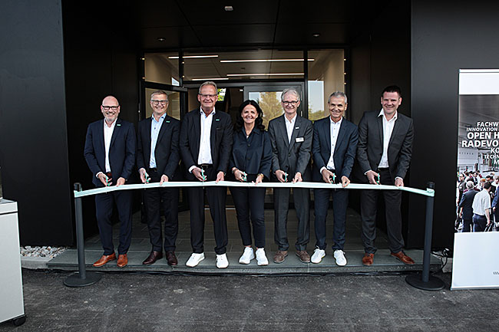

High-ranking Arburg delegation cuts the ribbon to reopen the ATC Radevormwald on 7 June 2024: Arburg Managing Partners Juliane Hehl (centre) and Michael Hehl (3rd from left) with Managing Directors Guido Frohnhaus (left) and Gerhard Böhm (2nd from left) as well as Ulf Moritz (ATC Director, 5th from left) with project leads Dieter Novotny (Architecture, 6th from left) and Florian Schmitz (Building Services Engineering, 7th from left).

Opening ATC Radevormwald_50

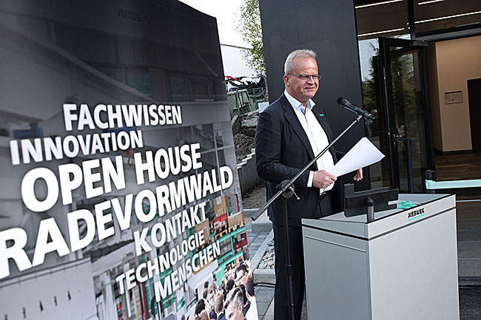

Michael Hehl, Arburg Managing Partner and spokesperson for the management team, officially opened the modernised ATC Radevormwald on 7 June 2024.

Opening ATC Radevormwald_370

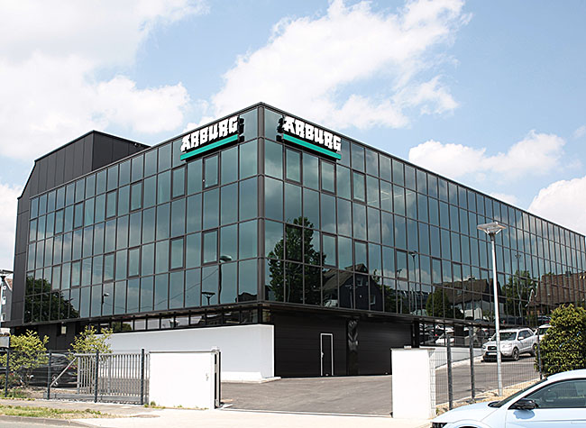

Reopening of the ATC Radevormwald: the comprehensive renovations and modernisations included installing photovoltaic and geothermal systems, a triple-glazed glass facade and efficient roof insulation.

Opening ATC Radevormwald_138

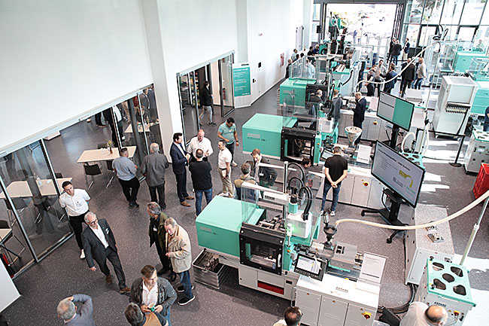

Open day: the customers and partners took full advantage of the opportunity to take in the modernised ATC Radevormwald. All seven Allrounder machines were in operation, showcasing interesting applications live.

Opening ATC Radevormwald_222

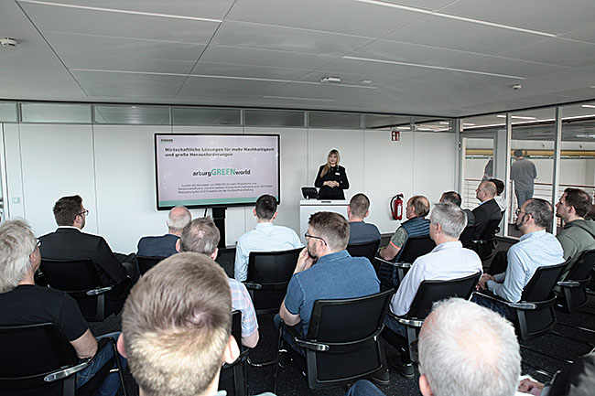

The programme of events marking the reopening of the ATC Radevormwald was rounded off with fascinating presentations, among other things on the hot topic of sustainability.

Photos: ARBURG
Photo download:
https://media.arburg.com/web/ad9f7ab56e820bcd/press-review-atc-radevormwald-2024

Press release
File: ARBURG press review reopening ATC Radevormwald 2024_en_GB.doc
Characters: 4,984
Words: 747

This and other press releases are available for download from our website at www.arburg.com/de/presse/ (www.arburg.com/en/press/)

Contact
ARBURG GmbH + Co KG
Press office
Susanne Palm
Dr Bettina Keck
Postfach 1109
72286 Lossburg, Germany
Tel.: +49 7446 33-3463
Tel.: +49 7446 33-3259
presse_service@arburg.com

About Arburg
The German family-owned company Arburg is one of the world's leading manufacturers of plastic processing machines. The product portfolio includes Allrounder injection moulding machines with clamping forces between 125 and 6,500 kN, freeformers for industrial additive manufacturing as well as robot systems, customer- and industry-specific turnkey solutions and other peripheral equipment.
Arburg is a pioneer in the plastics industry when it comes to energy and production efficiency, digitalisation and sustainability. The "arburgXworld" range comprises all digital products and services, and is also the name of the customer portal. The strategies for resource efficiency and circular economy as well as all aspects and activities related to this are combined in the "arburgGREENworld" range.
Arburg's central goal is to enable customers to manufacture their plastic products, whether one-off parts or high-volume production, in optimal quality and at minimum unit costs in a way that saves resources and is sustainable. The target groups include the automotive and packaging industries, communication and entertainment electronics, medical technology and the white goods sector.
An international sales and service network guarantees first-class, local customer support. Arburg has its own organisations at 36 locations in 26 countries and, together with trading partners, is represented in over 100 countries. Production takes place at the German headquarters in Lossburg. Of a total of around 3,800 employees, some 3,200 work in Germany while around 600 are based in Arburg organisations around the world. Arburg is certified in accordance with ISO 9001 (quality), ISO 14001 (environment), ISO 27001 (information security), ISO 29993 (training) and ISO 50001 (energy).
Further information about Arburg can be found at www.arburg.com.

