Arburg at MSV 2024
Arburg presents hybrid machine technology

- Exhibit: hybrid Allrounder 470 H
- Expertise: injection moulding technology and turnkey
- Added value: service and consulting

Lossburg, 01.07.2024
Arburg is a permanent fixture at the international engineering fair in Brno, Czech Republic. At MSV 2024, being held from 8 to 11 October, the company will present its extensive range of products and services on Stand 31 in Hall G1. An Allrounder 470 H featuring new hybrid machine technology will take centre stage. Other focus topics are service, advice and digital services.

"We are experiencing a growing demand for advanced injection moulding technologies just as we are for efficient and sustainable production solutions", says Dr Daniel Orel, Managing Director of the Arburg subsidiaries in the Czech Republic and Slovakia, describing the signs of a market recovery in his countries, "At MSV, we will be showing trade visitors how they can use our machines and draw on our services to make their production more efficient and take their company forward. We are here to demonstrate our technological leadership in plastics processing and our commitment to achieving customer satisfaction."

Hybrid machine technology reduces costs and cycle time
A 470 H "Premium" Allrounder with a clamping force of 1,000 kN will take centre stage at the trade fair. The injection moulding machine from the Hidrive series featuring new hybrid machine technology is extremely good at saving energy and conserving resources, and is efficient in production, reliable and user-friendly.
The new Hidrive (H) Allrounder features impressive modular, adaptable drive systems that can harness the benefits of both electric and hydraulic technology - namely speed and precision paired with power and dynamics. Arburg’s finely graduated hybrid machine technology is comparable to all-electric machines in terms of dry cycle times and injection speeds. Another great advantage is the resource-efficient oil management concept, which requires around 35 per cent less oil; plus, the oil is preheated using waste heat from the machine.
The new hybrid Allrounder H is an energy-saving alternative to hydraulic machines and an economical alternative to electric machines, unlike anything previously available on the market. It is currently available in sizes 470, 520 and 570, as well as in the performance variants "Comfort", "Premium" and "Ultimate".

Broad range of products and services
"We offer solutions for various sectors, such as automotive, consumer goods and medical, which call for high-quality and efficient manufacturing technologies," explains Dr Daniel Orel. "Alongside our expertise in injection moulding technology, we set great store by our comprehensive range of services including reliable maintenance, rapid support and one-to-one advice."

Digitalisation: demo version of "arburgXworld"
Visitors to MSV will see how digitalisation in modern injection moulding companies works in practice at a demo version of the "arburgXworld" customer portal with all apps for testing. Users can get started free of charge with apps such as MachineCenter, ServiceCenter and Shop, which offer a better overview, simple communication, increased flexibility and faster responses. This saves considerable time and costs in day-to-day operations.

Photos

182058

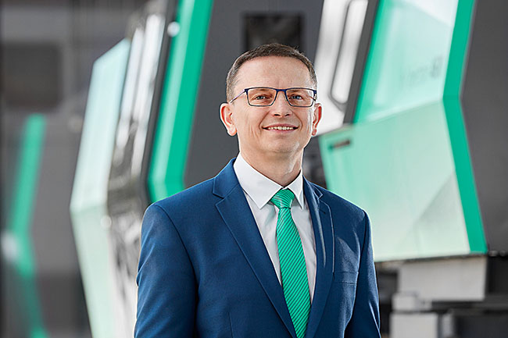

Daniel Orel, Managing Director of the Arburg subsidiaries in the Czech Republic and Slovakia and also, for a transitional period, the one in Romania founded in April 2024.

186073

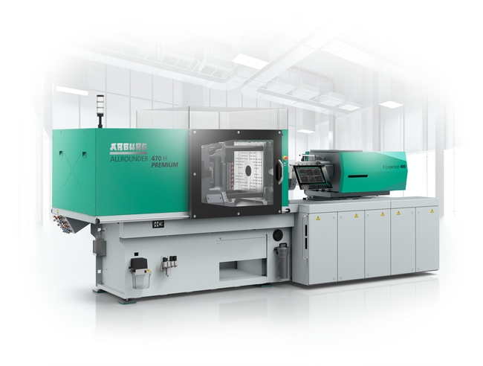

The Allrounder H featuring new hybrid machine technology is set apart by reduced acquisition and operating costs, as well as an optimised energy footprint and shorter cycle times. A size 470, "Premium performance variant of the machine will be on show at MSV 2024.

Photo: ARBURG
Photo download:
https://media.arburg.com/web/a7ef170bb8b3b1a4/press-preview-msv-2024

Press release
File: Pressevorbericht MSV 2024_de.docx
Characters: 3.114
Words: 469

This and other press releases are available for download from our website at www.arburg.com/de/presse/ (www.arburg.com/en/press/)

Contact
ARBURG GmbH + Co KG
Press office
Susanne Palm
Dr Bettina Keck
Postfach 1109
72286 Lossburg
Tel.: +49 (0)7446 33-3463
Tel.: +49 (0)7446 33-3259
presse_service@arburg.com

About Arburg
Founded in 1923, the German family-owned company is one of the world's leading manufacturers of plastic processing machines. The ARBURG family also comprises AMKmotion and ARBURGadditive, including innovatiQ.
Its portfolio includes injection moulding machines, 3D printers for industrial additive manufacturing, robotic systems and customer- and industry-specific turnkey solutions. It also includes digital products and services.
ARBURG is a pioneer in the plastics industry when it comes to energy and production efficiency, digitalisation and sustainability. ARBURG machines are used to manufacture plastic products for industries such as mobility, packaging, electronics, medicine, construction and equipment engineering, and leisure.
The company headquarters are located in Lossburg, Germany. In addition, Arburg has its own organisations at 37 locations in 27 countries and, together with trading partners, is represented in over 100 countries. Of a total of around 3,700 employees, some 3,100 work in Germany while around 600 are based in ARBURG organisations around the world.
ARBURG is certified in accordance with ISO 9001 (quality), ISO 14001 (environment), ISO 27001 (information security), ISO 29993 (training) and ISO 50001 (energy).
Further information can be found at: www.arburg.com, www.amk-motion.com and www.arburg.com/arburgadditive.

