Arburg at Fakuma 2024
Arburg has the solution: Focus on new machines and upcoming topics

- Round: arburgSOLUTIONworld is all about compelling upcoming topics
- Broad: eleven exhibits at the Arburg stand showcase a wide range of plastics processing solutions
- Slim: Allrounder with a new design saves space and increase efficiency

Lossburg, 02/07/2024
Arburg will be attending Fakuma 2024 from 15 to 19 October on Stand 3101 in Hall A3 with eleven exhibits, plus seven additional Allrounders on partner stands. The arburgSOLUTIONworld, augmented by a new exhibition wall on digitalisation including a transparent machine, will highlight compelling upcoming topics for customers. The German premiere of the electric Allrounder 720 E Golden Electric in a new design will be another highlight. Impressive applications and innovative processes, for sectors such as medicine, personal care, leisure and additive manufacturing for example, are set to be presented. Arburg will also be getting involved in the "Mould your future" initiative - not only on Careers Friday at the trade fair, but on the Saturday as well.

"We will have a total of 18 exhibits at Fakuma to showcase groundbreaking trends in plastics processing," explains Juliane Hehl, Managing Partner responsible for Global Marketing and Business Development. "The aim, as always, is to set our customers on the road to success. In the arburgSOLUTIONworld, we offer comprehensive advice on topics that are on everyone’s mind, as well as future-proof digital products and services. I am thrilled to be welcoming around a dozen trainees to our team in Friedrichshafen on the Friday and Saturday to support the careers campaign at the trade fair and to highlight the excellent prospects Arburg offers in terms of training, study courses and starting a career."

One-of-a-kind: arburgSOLUTIONworld
arburgSOLUTIONworld - the interactive exhibition area - will once again be the focus of attention at the trade fair. It bundles together Arburg’s comprehensive advisory and solution expertise in all aspects of plastics processing. Trade visitors will get specific answers to questions on compelling topics such as productivity increases, efficiency, sustainability, the lack of skilled workers and subsidies. Arburg experts will provide advice at the six stations situated around the four-metre-high LED column, and also at a completely new exhibition wall with an integrated transparent machine. This is where the digital products and services in particular will be brought to life for trade visitors.

New: electric machine - slimline design with a price to match
Following its world premiere at NPE in the USA and its European premiere in Poland, Arburg will be debuting its latest machine to the general public in Germany at Fakuma 2024: the 720 E Golden Electric hybrid Allrounder with a clamping force of 2,800 kN is a vertical extension to the range of the electric series of the same name. Its main advantages in a nutshell? A slim design with a price to match. The new machine is set apart by its electric precision, process stability and its extremely slimline installation area, offering high component quality with low investment costs and short delivery times. The exhibit at Fakuma uses a 24-cavity mould from Hack to produce razor covers, for example.

Versatile: 18 machine exhibits
With a total of 18 exhibits, Arburg will be demonstrating its extraordinarily broad range for the efficient production of plastic parts. Visitors will be able to see, for example, multi-component and paper injection moulding, recyclate and LSR processing, robotic systems, complex turnkey solutions and additive manufacturing. Alongside the new Allrounder 720 E Golden Electric already mentioned, exhibits on the Arburg stand will include:
- An electric Allrounder 630 A, also in the new slimline design, which produces a high-quality plastic glass from copolyesters. A new linear Multilift Select 16 robotic system performs the handling tasks.
- An Allrounder 570 H "Ultimate" with new hybrid machine technology presents a high-speed application for medical technology. Some 64 syringe plungers are manufactured in a material-optimised product design.
- Innovative paper injection moulding, a project by Arburg with its partners Model and Biofibre, will be demonstrated by an electric Allrounder 370 A: instead of plastic granulate, the exhibit turns paper pearls into positioning tools for furniture connectors. The new "aXw Control RecyclatePilot" ensures a stable shot weight.
- Sophisticated two-component injection moulding will be demonstrated on an Allrounder More 2000, which processes thermoplastics (PBT) and liquid silicone (LSR) to make ready-to-use spatulas. This application is automated by a Yaskawa six-axis robot.
- A turnkey system centred around a vertical Allrounder 375 V demonstrates how vacuum housings can be produced with space-saving firmly in mind. A Kuka six-axis robot is mounted within the footprint. The Arburg Turnkey Control Module (ATCM) is used to help seamlessly track material and process data.
- A production cell centred around an hydraulic Allrounder 470 C Golden Edition with Multilift Select 8 produces small plastic dolphins by a fully automated process. The material is a post-consumer recyclate (PCR) made from old fishing nets.
- An electric Allrounder 520 A produces flip-top closures for the personal care sector. Servo-electric direct drives from the subsidiary AMKmotion ensure speed and precision.
- A “transparent” Allrounder 270 A, which is integrated into the arburgSOLUTIONworld exhibition wall, provides a deeper insight into the electric drive components and the information technology networking system.

In addition: Career days at Fakuma
Under the motto "Mould your dreams, mould your future", Arburg is participating in the new Career Friday, initiated by the organiser Schall and the trade fair committees, and is extending this campaign to Saturday as well. The campaign is aimed at school pupils, students and jobseekers. At Fakuma 2024, they will gain an insight into the diverse career opportunities offered by the plastics sector. The Arburg stand will have experts and a team of trainees there especially for the event on hand to answer any questions. "Our sector offers a host of tremendous opportunities to get personally involved in solving important issues: the purpose often conjured up today is clear to see," emphasises Dr Christoph Schumacher, Vice President of Global Marketing at Arburg and member of the trade fair committee. "If you want to shape things, our sector is where you need to be. We look forward to welcoming as many curious young visitors as we can."

Photos

130401

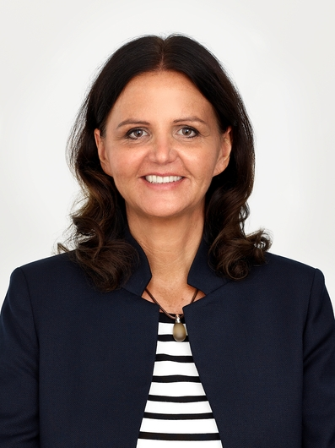

Juliane Hehl, Managing Partner, Global Marketing & Business Development.

arburgSOLUTIONworld Key Visual Fakuma 2024.

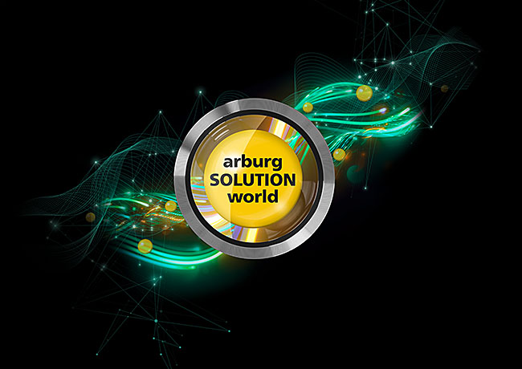

Once again, the focus of Arburg’s trade fair appearance will be the interactive arburgSOLUTIONworld exhibition area with a four-metre-high LED column and a new exhibition wall with an integrated transparent machine.

720 E GOLDEN ELECTRIC 2024

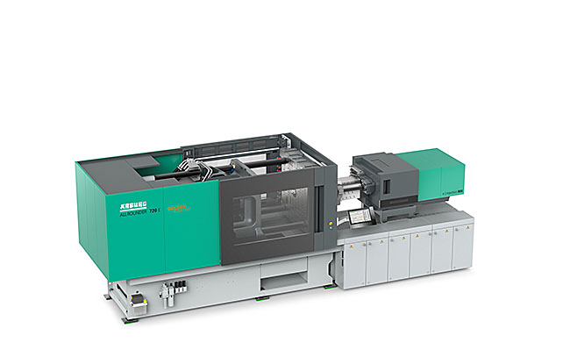

German premiers at Fakuma 2024: thanks to its new design and standardised equipment, the new Allrounder 720 E Golden Electric has an extremely slimline installation area and a price to match.

Photos: Arburg
Photo download:
https://media.arburg.com/web/3048c876350d254b/fakuma-2024-press-preview

Press release
File: Pressevorbericht Fakuma 2024_de.docx
Characters: 6,322
Words: 973

This and other press releases are available for download from our website at www.arburg.com/de/presse/ (www.arburg.com/en/press/)

Contact
Arburg GmbH + Co KG
Press office
Susanne Palm
Dr Bettina Keck
Postfach 1109
72286 Lossburg
Tel.: +49 (0)7446 33-3463
Tel.: +49 (0)7446 33-3259
presse_service@arburg.com

About Arburg
Founded in 1923, the German family-owned company is one of the world's leading manufacturers of plastic processing machines. The ARBURG family also comprises AMKmotion and ARBURGadditive, including innovatiQ.
Its portfolio includes injection moulding machines, 3D printers for industrial additive manufacturing, robotic systems and customer- and industry-specific turnkey solutions. It also includes digital products and services.
ARBURG is a pioneer in the plastics industry when it comes to energy and production efficiency, digitalisation and sustainability. ARBURG machines are used to manufacture plastic products for industries such as mobility, packaging, electronics, medicine, construction and equipment engineering, and leisure.
The company headquarters are located in Lossburg, Germany. In addition, Arburg has its own organisations at 37 locations in 27 countries and, together with trading partners, is represented in over 100 countries. Of a total of around 3,700 employees, some 3,100 work in Germany while around 600 are based in ARBURG organisations around the world.
ARBURG is certified in accordance with ISO 9001 (quality), ISO 14001 (environment), ISO 27001 (information security), ISO 29993 (training) and ISO 50001 (energy).
Further information can be found at: www.arburg.com, www.amk-motion.com and www.arburg.com/arburgadditive.

