Energy saving tops agenda at thrilling “Anniversary Days” exhibition

- Energy saving practices a major theme at special centenary “Anniversary Days”
- Launch of new hybrid Allrounder 470 H, packed with energy-saving features
- UK and Ireland customers comment on the scale and innovation of the latest Anniversary Days annual exhibition

Warwick, UK, 29/03/2023
Energy saving was a big theme at Arburg’s Anniversary Days 2023, the annual global customer meeting in Lossburg, Germany, which attracted 5,700 visitors from 53 countries this year. The event, which ran from 8 to 11 March, changed names from the normal “Technology Days” to celebrate 100 years of the Hehl family company. A great deal of space was devoted to pioneering green applications as well as to digitalisation and automation. With lots of practical examples on display in the Efficiency Arena, Arburg lived up to its claim of combining sustainability and production efficiency through high-quality technology solutions.

Energy consumption is on everyone’s minds as energy prices rocketed above inflation and have remained high; Arburg has responded with its "Action Plan: Energy" exhibit and a report full of tips to save energy and reduce costs in injection moulding production. These include settings to optimise energy requirements through the entire production process, and documenting the metering of consumption accurately, at Basic, Extended and Complete levels, showing customers how to meter their energy in, for example, the start-up and cooling phases and on peripheral equipment.

Simple and advanced machine upgrades can save energy with very little effort, and the digital display of energy requirements can be rendered on ALS, Arburg host computer system. A new energy efficient machine was launched to celebrate the company anniversary, a hybrid Allrounder 470 H that was exhibited against a golden backdrop. Its technical features include a new oil management concept, flow rate splitting for simultaneous movements of hydraulic secondary axes and the extended use of the Arburg servo hydraulic system – again for energy.

As with other Technology Days in recent years, Arburg demonstrated its expertise in and its devotion to sustainability, digitalisation and automation, especially in the Efficiency Arena. Here, nine stations – six on the topic of arburgGREENworld and three on arburgXworld – Arburg and selected partners in the entire value chain demonstrated how digitalisation and innovative solutions enable a sustainable circular economy.
To demonstrate all three themes in one, a hybrid Allrounder produced Fischer dowels from the "Greenline" series, a product consisting of 50 percent castor oil. The machine was equipped with the recyclate package and Arburg's new "aXw Control RecyclatePilot", which ensures a stable shot weight by means of adaptive process control and can compensate for fluctuating material qualities. The sprues were ground immediately and fed back into the process as post-industrial recyclate (PIR).

The exhibition area covered the entire company, and in addition to more than 50 exhibits and innovative applications, Arburg shared its deep expertise in important topics such as sustainability, digitalisation, and automation.

Several UK and Ireland customers commented on the scope of the expo:

Danny MacFarlane, Managing Director, Ellis Patents, said: “It was excellent. I last visited Technology Days 11 years ago and the Lossburg factory has grown so much, as have the machines and applications. It’s very impressive to see Arburg now. Our technical manager joined me and he was blown away. We are trying to bring more work in-house at Ellis Patents, which is what Arburg has done – more vertical integration.
He added: “We were particularly interested in reprocessed polymers, using more recycled plastic in the product, because our company takes sustainability very seriously. It was good to see Arburg’s control processes – with bigger variation by combining used and virgin polymers, more control is needed.
“All companies need to do more to fight climate change. At Ellis we have just installed 800 solar panels on the roof of the facility. We are keen to learn about any process we can use to decrease carbon emissions.”

Justin Davies, Managing Director at Tex Plastics, said:
“This was the third time I have been to Technology Days. It’s always very impressive, it sets the standard in the plastics industry for innovation.
Energy management is critical to us at the moment. Arburg has a system that measured the energy consumption per job and per cycle – this was very interesting and we could apply this at Tex Plastics.
“Seeing all the different technologies – updated derivatives if the things that they have been doing well for years – and they are always moving forward with the innovation.”

Andrew McGuiness, Technical Operations Manager, Harwin plc was impressed by the expo, and showed that the annual concept works: “Many of the best technical improvements that I have brought into Harwin, have come from visiting the Technology Days.”

Colin Tirel, Managing Director, Arburg Ltd., agreed that there is no substitute for touching and discussing the technology on-site: “The annual Technology Days really is an excellent showcase to demonstrate the wide range of application competence that we have. It is a pleasure to take potential and existing customers alike to our state-of-the-art manufacturing facility, from which they can form their own opinion in terms of our capability, sustainability and strength.
“They really appreciate the strong partnerships that we can create and forge long-term relationships with them for mutual benefit. We often say that this event is larger than most independent plastics exhibitions around the world – therefore it is a true technical experience that should not be missed. So book now for next year!”

+++ Special customer event in May +++
Arburg Ltd. in Warwick is hosting a special event to celebrate the Hehl family company centenary on May 17th. The new hybrid Allrounder 470 H Comfort with energy-saving features will be demonstrated.

Contact Donna White for more details: donna_white@arburg.com or Tel. 01926 457000.

Images

ARBURG 187698-impressions-anniversary-days-2023

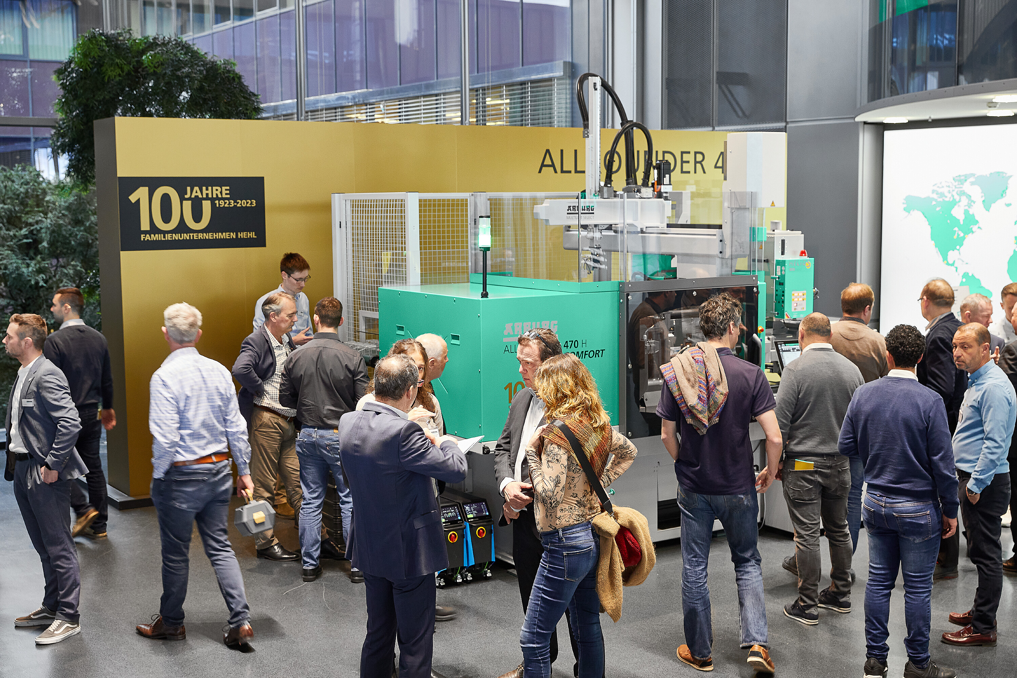

The new, energy-efficient hybrid Allrounder 470 H on display at Anniversary Days. Arburg Ltd. will have a variant of this machine at its special 100-year anniversary event in May.

187785

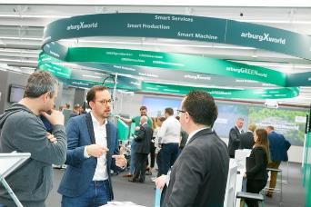

The Efficiency Arena with its focus on arburgGREENworld and arburgXworld was once again a key port of call this year. Together with selected partners, innovative solutions relating to resource conservation, digitalisation and the circular economy were presented.

188016
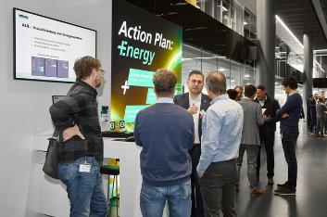
Energy efficiency was an important theme at Anniversary Days 2023. The "Action Plan: Energy", with which Arburg offers its customers, for example, comprehensive advice, machine upgrades and energy measurements, generated a correspondingly high response.

Photos: ARBURG

About Arburg
German family-owned company Arburg is one of the world's leading manufacturers of plastic processing machines. Its product portfolio encompasses Allrounder injection moulding machines with clamping forces of between 125 and 6,500 kN, the Freeformer for industrial additive manufacturing and robotic systems, customer and industry-specific turnkey solutions and further peripheral equipment.
Arburg is a pioneer in the plastics industry when it comes to production efficiency, digitalisation, and sustainability. The “arburgXworld” program comprises all digital products and services and is also the name of the customer portal. The company’s strategies regarding the efficient use of resources and circular economy, as well as all related aspects and activities, are outlined in the “arburgGREENworld” program.
Arburg’s central aim is for customers to be able toproduce their plastic products, from one-off parts to large-volume batches, in optimum quality at minimum unit costs. The target groups include, for example, the automotive and packaging industries, communication and entertainment electronics, medical technology and the white goods sector.
An international sales and service network ensures first-class customer support at a local level: Arburg has its own organisations at 34 locations in 25 different countries and, together with its trading partners, is represented in more than 100 countries. Its machines are produced exclusively at the company's German headquarters in Lossburg. Of a total of roughly 3,500 employees, around 2,900 work in Germany. About 600 further employees work in Arburg's organisations around the world. Arburg has triple certification, in accordance with ISO 9001 (quality), ISO 14001 (environment) and ISO 50001 (energy).

Further information about Arburg can be found at www.arburg.com

